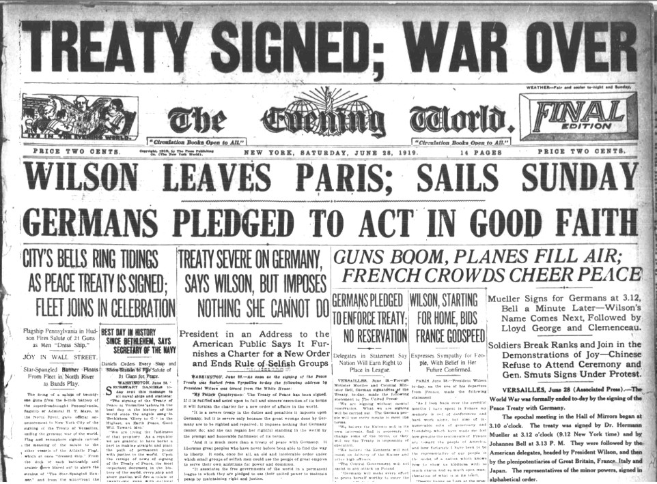
Source 1 – American Newspaper

"We were preparing not Peace only, but Eternal Peace. There was about us the halo of some divine mission. We were bent on doing great, permanent noble things."
-- Harold Nicolson, British delegate to the 1919 Paris Peace Conference

Source 2

- Explain the historical context of Source 1. Include the relevant events, people and ideas depicted or represented in the source. (4 marks)
- Compare and contrast the purpose of Sources 1 and 2. (5 marks)
- Explain the message of Source 3. (3 marks)
- Identify how, and discuss why, Sources 3 and 4 are contestable. (6 marks)
- Using your knowledge of the whole period of study, evaluate the importance of the themes, ideas and/or events represented in the four sources. (7 marks)

